**Olivia**

**Learning Aim A: Understand the principles of website development**

In learning aim A I will be comparing two separate websites with the same field of jewellery. I will be evaluating the websites by comparing details and explaining how it is a strength or a weakness for the website. I will be looking at the details and examining if they affect the user’s experience. Me evaluating these websites will help to inspire me when creating a website but still add original features. From doing this is will allow me to get a better understanding of web development.

**The Purpose of Websites**

Websites have many different purposes depend on what type of website it is. However, the main purpose on many websites is to promote and display information. For example, an e-commerce website purpose is to sell goods e.g., Amazon. A small business website main purpose would be to promote their business. BBC Bitesize is an educational website therefor its primary purpose is to display information. Websites have different purposes and perform different functions. Some websites can be interactive, and others may not be. The ability to make websites interactive create opportunities for new creative websites to be created.

**Two Websites**

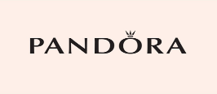The two websites that I will be comparing are <https://uk.pandora.net/en/> and <https://www.nomination.com/uk_en/>. These websites are both popular jewellery brands.

**Target Audience**

Pandoras target audience is directed for consumers. Females that are aged 18-54. However, it is also targeted for adolescent girls. The website contains lots of pink and most of the images are of females. It is important that pandora can identify their target audience, so they are able to create a website that is best suited to their audience. Pandoras website is targeted for their target audience as the primary colour is pink which is commonly associated with females.

Nominations target audience is once again directed towards women aged 18-54 and adolescent girls. There is also a “for men” range on the website. Nomination has identified their target audience and therefor have been able to create a website appealing for their audience. Nomination has utilised this as the website has neutral colours and has images of both genders ranging in age.

**Type of Website**

Pandora is an ecommerce website; its target audience is consumers. It allows users to carry out transactions easily and conveniently on PCs and mobile devices. People can buy goods over the internet, this is beneficial to Pandora as people can purchase their products anywhere and at any time. Pandora sells jewellery.

Nomination is a ecommerce website therefor its targeted for consumers. Users can carry out transactions easily and conveniently on PCs and mobile devices. People are able to buy goods over the internet at any time or anywhere, nomination sells jewellery.

**Purpose of Website**

The main purpose of these websites is so that people can buy their jewellery online. Another purpose is that people can browse the website and see what they sell. Both websites promote their brand meaning that a larger number of people will be interested then leading to more sales from the companies. These companies have websites so that their goods can be bought at any time and any place making the companies have more sales.

**Content Based**

**Pandora**

Pandora has many different interactive features. It is a web2.0 and it is dynamic, not static as it has images, videos and feedback. Some interactive features include a search bar, people can use the search bar to find more specific results. Users can also create an account that they can log into so they can access their account on different devies. Pandora has the option to leave reviews by the consumers who have purchased an item, interactive as it allows communication between consumers and the brand. The Pandora website also has a google map embedded where users can locate the nearest store. The shopping bag allows users to save products they wish to purchase and then can purchase at later time and have easy access when doing so. The hypertext logo means that users can click on the logo when on any page of the website and it will return the user to home page of the Pandora website.

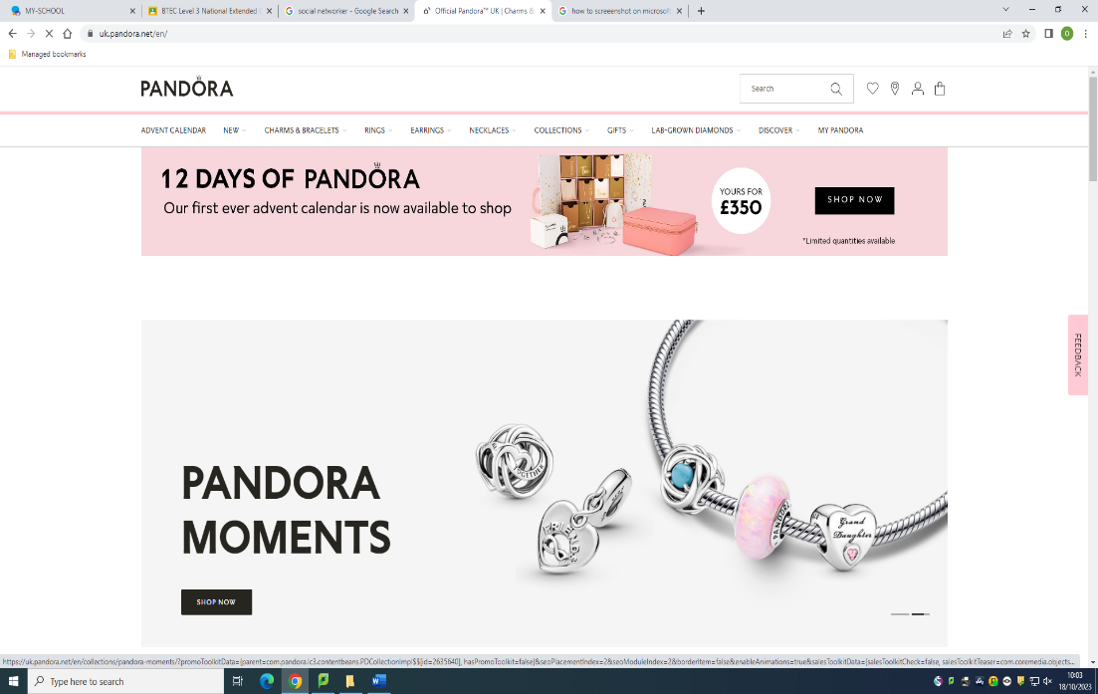

Hypertext logo.

Feedback option

Search Bar

Maps, login to account and shopping bag

Scrolling Images

**Nomination**

Nominations website contains reviews allowing for customer feedback available to see by all users and the brand making it very interactive. The website also has images and videos which are all examples of what a web2.0 website contains. It’s not all just reading the website has lots of images to present their products making it more of an interactive website. Nomination allows users to log in to an account that they n then access this account on various devices. The website also contains search bar so users can search for specific products. Nomination website has multiple hyperlinks which will take users to different pages throughout the website. Nomination website contains scrolling images making the website dynamic. The pop up is also a interactive feature.

**Website Layout**

The pandora website has a table format consisting of multiple rows and columns. The website has a banner at the top of the page and a footer at the bottom of the page. It has a horizontal navigation bar and has nine pages. Pandora has a consistent website layout being very clear and easy to understand making it a good website layout.

The nomination website similarly has a table format consisting of rows and columns. The website has a horizontal navigation bar below the banner at top of the page and has nine pages. The website also has a footer at the bottom of the page. The layout of the website is user friendly as it is easy to navigate and is easy to use.

**Requirements**

**1.User Friendly**

Pandora is user friendly as it is simple to navigate around the website. Everything is captioned accurately so customers can easily find what they are looking for. Pandora website has quick loading times. Pandora website is easy to use and to understand. The website contains white space making it user friendly as allows users to rest eyes.

Nomination is a user-friendly website as it is very accessible to all users it also has a very clear format making it easier for customers to use the website and for users to understand the website. Nomination website loads at an efficient time when connected to broadband. Nomination having a user friendly website will allow users to have satisfactory experience when using.

**2.Consistent**

Pandora has many consistent features such as colour consistency, throughout the website the colour theme is a pastel pink, white and black. The website uses the same font for all the pages with titles and subheadings in bold. The images all have the same theme either being products being sold or models displaying the products.

Nomination is similar to Pandora as the website is consistent as well. Nomination is a good example of consistency in a website as it contains a neutral colour theme on all pages. Nomination is consistent with the font and images. Making website appear more professional.

**3.Navigational**

Pandoras website is easy to navigate through. All pages are linked together. You can access any page from any page. It is easy for users to find the information they need. The navigation bar is located below banner at top of page making it simple for users to change from page to page without having to scroll.

Nominations website can also be easy for users to navigate to find the information they are looking for. All pages are linked to each other so they can be accessed on any page. The navigation bar is below the banner at top of screen allowing users to access all pages on the website from any page on the website.

**4.Customisable**

Pandora has customisable features for example the website can recommend products specifically for you. Another customisable feature is the ability to filter out options, so you are left with the ideal product. Pandora also has a search bar allowing users to be able to specifically search for what they want which is a customisable feature.

Nomination has the same customisable features. Website can recommend products specifically for you. Another customisable feature is the ability to filter out options, so you are left with the ideal product. Nomination has a search bar also making it more customisable.

**5.Responsive**

Pandoras website is flexible on a laptop and on a phone.

It is the same on google and safari web browsers.

Has adapted as on the phone it has a menu option to see all the headers whereas on the laptop it is present at the top.

Nomination website is accessible on both a laptop and phone.

Instead of having the navigation bar at the top on the laptop, on the phone it’s a drop menu option.

The website loads the same on google and safari web browsers.

**Principles of website design**

**1.Usability**

Pandora is an easy-to-use website as it is user friendly. Everything is captioned and accurate, has a quick loading time. Pandora website content is flexible and works on all browsers and devices.

Nomination is an easy-to-use website. Nominations website is user friendly therefor it should be accessible to everyone The Nomination website content is flexible and works on all browsers and devices.

**2.White Space**

The Pandora website contains white space this is beneficial as stops the web pages from looking cluttered and messy. The white space also lets users’ eyes take a break and feel less overwhelmed.

The Nomination website also contains white space. This white space allows users eyes to have a break. The white space also stops the web pages from being cluttered and messy looking.

**3.Site Layout**

On the Pandora website there is a template. The navigation bar, header and footer are the same on all the web pages. This makes the website easy to use and understand.

Nomination website has made use of a template which allows a good site layout that is uncomplicated, has a clear navigation and is intuitive. All the web pages have a similar structure.

**4.Typography**

Pandora uses a clear font that is user friendly. The font used is San serif, this is easier to read and clearer. The same font is used all on web pages.

Nomination uses a clear font that is user friendly. The font used is San serif, this is easier to read and clearer. The same font is used all on web pages.

**5. Alignment**

Pandoras text is all aligned to the left, this shows consistency on the website.

Nominations text is centre aligned. The web site has consistency with this.

**6. Clarity**

Pandora website is very clear. Everything is laid out simple so that is easy for users to understand.

The Nomination website is clear and easy for users to understand. The contact details are laid out effectively so that users can easily contact Nomination.

**7.Accuracy**

Everything on the Pandora website is accurate. The text and photo accurately describe the product. The website gets updated regularly with either new products or old products going out of stock. There is no spelling or grammar mistakes.

On the Nomination website all information is accurate. The website is updated regularly and there is no spelling or grammar mistakes. The text and images are not misleading but accurately describe the product to users.

**8. Content**

All the content on Pandora website is accurate and consistent in style. The content includes the movie, images, and text.

All the content on Nomination website is accurate and consistent in style. The content includes the movie, images, and text.

**Media And Objects**

**1. Position**

Pandora has placed their media in a strategical position. They have placed media where it can be easily seen and successfully grab the attention of users.

Nomination has positioned their media where is can be seen easily and therefor, they grab the attention of users. The media is placed in a strategical position.

**2.Colour**

Pandora website uses the colours pink, white and black primarily with the odd pop of a different colour. These colours fit the Pandora branding and attract users’ attention. Pandora website uses colours that aren’t overwhelming. However, the pink can be a bit too much at times.

The Nomination website doesn’t have a distinctive colour theme but the colours that they use go together well making it attract users’ attention. The colours used are not overwhelming but simply pleasing on the eye.

**3. Size**

Unable to read due to an error in sizing.

Sizing of media and objects are important. On Pandoras website there is a complication with sizing because the sizing is off users are unable to read the text.

There are no errors with sizing on Nominations website on a laptop however on a phone there is. The movie can be seen fully on laptop and on phone only half can be seen.

**4. Appropriateness**

Pandoras content used is images of their products this add effectiveness to the web pages as it is advertising what they are selling.

Nominations content on the web page adds effectiveness as it is images and videos of the products, they are selling this allows users to see what they look like.

**Creativity and Innovation**

Pandoras website does not have an unconventional layout and is basic. There is popup photos and text which gives the website originality. There is also a scrolling text at the bottom of homepage. Pandoras website has a balance of white space and colour. This allows the user to rest their eyes and that the page isn’t so overwhelming with colour. The website does not contain any out of the box ideas but is quite simple which can still attract users because of the simplicity. The website does contain a lot of animations which can make going through the website an enjoyable experience. Pandora has created a creative and innovative website.

Nominations website is also very basic with a conventional layout. There is a balanced mixture of static and non-static images. Nomination has a unique layout which can be seen as out of the box by users. Nominations colour scheme is aesthetically pleasing and has white space so users can rest their eyes, so they aren’t overwhelmed by colour. Nomination has a creative and innovative website which will attract users.

**Search Engine Optimisation**

Search engine optimisation is a set of techniques used to increase the number of visitors to a website. Using the techniques of search engine optimisation, it ensures that the website appears high on the list of results returned by a search engine for related search terms. It is important for Pandora and Nomination as users of search engines tend to click on the first relevant link that comes up. Then by appearing at the top of search engine it will increase the potential of advertising their products and services.

Firstly I typed “pandora” into the search engine. The outcome was as expected as the pandora website was the first link to appear.

I typed “nomination” into the search enging and as expected the outcome was that the nomination website was the first link to appear.

I put a keyword into the search engine so that it would return matching and relevant results. Pandoras key word was charm bracelet as that is the most popular product from pandora. When I typed “charm bracelet” into the search engine the pandora website was the first link to appear.

I put a keyword into the search engine so that it would return matching and relevant results. Nominations key word was Italian jewellery as that is what Nomination prides itself in. When I typed “Italian jewellery” into the search engine the nomination website was the first link to appear.

Lastly I did a broad search. I entered “jewellery” into the search engine to see what the results are. Pandora was the sixth website to appear out of the relevant links. Nomination website did not appear on the first page when “jewellery” is typed into the search engine.

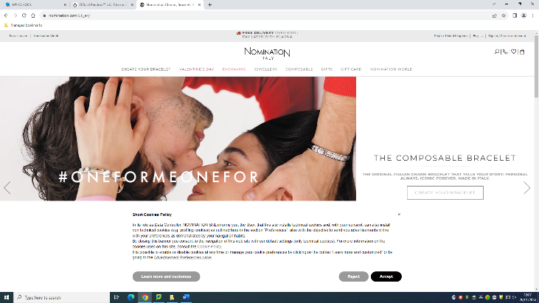

**Cookies**

Nomination asks for cookies. A cookie is a small file of letters and numbers that is downloaded on to your computer when you visit a website. Cookies are used by many websites and can do a number of things, eg remembering your preferences, recording what you have put in your shopping basket, and counting the number of people looking at a website.

Pandora didn’t ask for permission of cookies.

**Bibliography**

<https://www.nomination.com/world/>

Date accessed 9/9/23.

<https://uk.pandora.net/en/>

Date accessed 9/9/23.

<https://www.cloudflare.com/learning/privacy/what-are-cookies/>

Date accessed 15/9/23.

<https://www.techtarget.com/whatis/definition/Web-20-or-Web-2#:~:text=Web%202.0%20are%20websites%20and,connectivity%20and%20enhanced%20communication%20channels>.

Date accessed 20/9/23.

<https://www.bluehillsdigital.com/articles/website-purpose-seven-types/>

Date accessed 23/9/23.

<https://sell.amazon.com/learn/what-is-ecommerce>

Dare accessed 24/9/23.

<https://fonts.google.com/knowledge/glossary/sans_serif>

Date accessed 29/9/23.